Istanbul Technical University- Fall 2010

BLG381E, Advanced Data Structures

Report for Homework 2
Name: Aykut
LastName: Akın
Student ID: 040080177
Email: akinay@itu.edu.tr
Date: 01.12.2010
Instructor: Zehra Çataltepe

Question | Q1 | Q2 | Q3 | Q4 | TOTAL
Total Points | 30 | 30 | 30 | 10 | 100
Expected Points | 30 | 30 | 30 | 5 | 95

Q1)

void quicksort_start(vector<long long> &a, string command)
/******************************************************************************This function determines the input file name and output file name. Then, data is read and quicksort function is called. Finally, sorted output is written to ‘data?out_quick.txt’.
*****************************************************************************/

void quicksort(vector<long long> &a,int p, int r)
/******************************************************************************Quicksort algorithm from lesson slides.
*****************************************************************************/
int randomized_partition(vector<long long> &a,int p, int r)
/******************************************************************************
Randomized partition algorithm from lesson slides.
*****************************************************************************/

int partition(vector<long long> &a,int p, int r)
/******************************************************************************
Partition algorithm from lesson slides.
*****************************************************************************/

Q2)

void radixsort_start(vector<long long> &a, string command)
/******************************************************************************This function determines the input file name and output file name. Then, data is read and the digit of the maximum number is found. After that, radixsort function is called. Finally, sorted output is written to ‘data?out_radix.txt’.
*****************************************************************************/
void radixsort(vector<long long> &a,int d)
/******************************************************************************Radixsort algorithm from lesson slides.
*****************************************************************************/
void counting_sort(vector<long long> &a, int d)
/******************************************************************************
Counting sort algorithm from lesson slides. But, this algorithm has a little bit diffences. Our input data numbers have not only one digit so we must split the numbers to digits. We are doing this job with the help of the divider variable and mod10.
*****************************************************************************/

Q3) Fill up the tables below based on your sorting program outputs on each dataset.

Data1.txt  N | Heapsort (ms) | Quicksort (ms) | RadixSort (ms)
100 | 0 | 0 | 0
1000 | 0 | 0 | 0
10000 | 6 | 4 | 1
100000 | 78 | 170 | 18
1000000 | 956 | 14400 | 184

Data2.txt | Heapsort (ms) | Quicksort (ms) | RadixSort (ms)
100 | 0 | 0 | 0
1000 | 0 | 0 | 0
10000 | 6 | 3 | 4
100000 | 76 | 39 | 37
1000000 | 953 | 506 | 365

Data3.txt | Heapsort (ms) | Quicksort (ms) | RadixSort (ms)
100 | 0 | 0 | 0
1000 | 0 | 0 | 1
10000 | 6 | 3 | 6
100000 | 78 | 43 | 75
1000000 | 1007 | 590 | 807

Q4)

- Heapsort has no relation with the input interval. Its sorting time has relation with input size.
- Quicksort has better performance than others for big intervals.
- Radixsort is going slower when the digit number becomes larger.

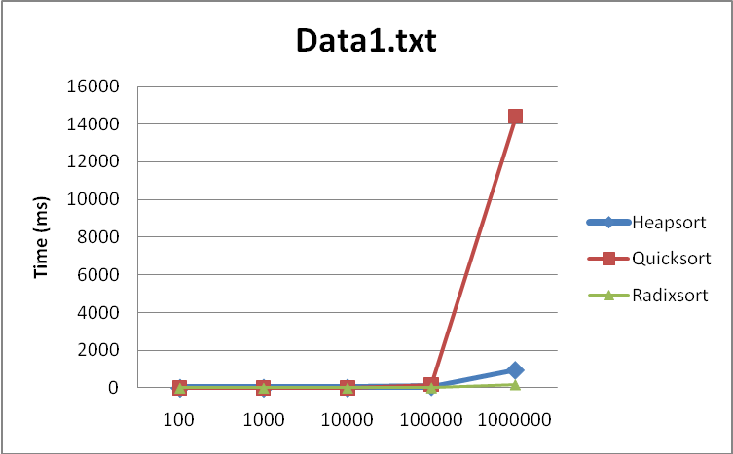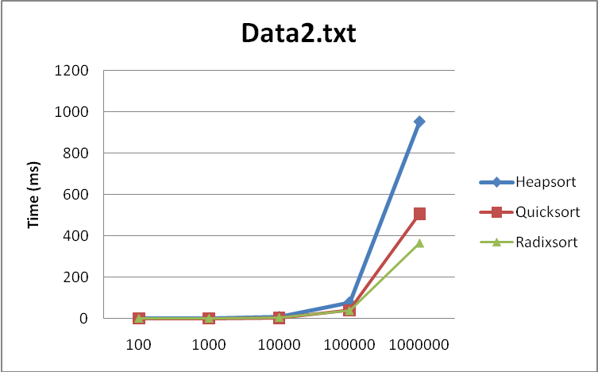
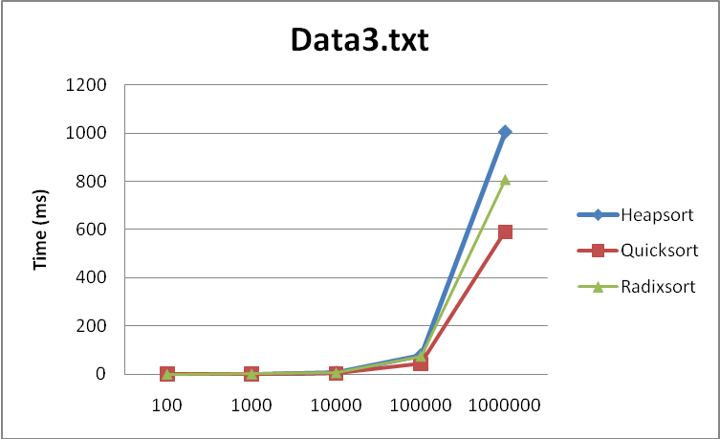

Question: How much time (in minutes) did you spend:

Procrastinating | 0 minute
Understanding the homework | 0 minute
Understanding the pseudocode | 0 minute
Writing the code | 100 minutes
Testing the code | 30 minutes
Getting the outputs and preparing the report | 20 minutes

